

**MINI PROJECT**

**OBJECT DETECTION AND CLASSIFICATION APP**

Project Report

**Institute of Engineering & Technology**

**Submitted By -**

###### Devarsh Raj (191500259)

**Under the Supervision of Mr. Amir Khan**

**Department of Computer Engineering & Applications**

Department of Computer Engineering and Applications GLA University, 17 km. Stone NH#2, Mathura-Delhi Road, Chaumuha, Mathura – 281406 U.P (India)

## Declaration

I/we hereby declare that the work which is being presented in the Bachelor of technology. Project **Object Detection and Classification App** in partial fulfillment of the requirements for the award of the ***Bachelor of Technology*** in Computer Science and Engineering and submitted to the Department of Computer Engineering and Applications of GLA University, Mathura, is an authentic record of my/our own work carried under the supervision of **Mr. Amir Khan, Dept. of CEA, GLA University.**

The contents of this project report, in full or in parts, have not been submitted to any other Institute or University for the award of any degree.

**Sign**: *Devarsh Raj*

**Name of Candidate**: Devarsh Raj

**University Roll No**.:191500259

Department of Computer Engineering and Applications GLA University, 17 km. Stone NH#2, Mathura-Delhi Road, Chaumuha, Mathura – 281406 U.P (India)

## Certificate

###### This is to certify that the project entitled Object Detection and Classifier App, carried out in Mini Project – I Lab, is a bonafide work by Devarsh Raj and is submitted in partial fulfillment of the requirements for the award of the degree Bachelor of Technology (Computer Science & Engineering).

**Signature of Supervisor:**

**Name of Supervisor:** Mr. Amir Khan

**Date:**

Department of Computer Engineering and Applications GLA University, 17 km. Stone NH#2, Mathura-Delhi Road, Chaumuha, Mathura – 281406 U.P (India)

**ACKNOWLEDGEMENT**

Presenting the ascribed project paper report in this very simple and official form, we would like to place my deep gratitude to GLA University for providing us the instructor Mr. Amir Khan.

He has been helping us since Day 1 in this project. He provided us with the roadmap, the basic guidelines explaining on how to work on the project. He has been conducting regular meeting to check the progress of the project and providing us with the resources related to the project. Without his help, we wouldn’t have been able to complete this project.

And at last, but not the least we would like to thank our dear parents for helping us to grab this opportunity to get trained and also my colleagues who helped me find resources during the training.

###### Thanking You

**Sign**: *Devarsh Raj* **\**

**Name of Candidate**: Devarsh Raj

**University Roll No**.:191500259

**CONTENTS**

1. ABSTRACT
2. DEEP LEARNING
   1. Introduction
   2. What happens inside the neuron?
   3. How does and Artificial Neural Network Learn?
   4. Weighted Sum
   5. Activation Function
3. CONVOLUTION NEURAL NETWORKS
   1. ANNs
   2. CNN Architecture
   3. Convolutional Layer
   4. Pooling Layers
   5. Training
4. WHAT IS YOLO V3?
   1. What is Yolov3
   2. Why is Yolo algorithm important?
   3. How the Yolo algorithm Works
   4. Residual blocks
   5. Bounding box
   6. Intersection over Union (IOU)
5. SCREENSHOTS
6. APPLICATIONS
7. CONCLUSION
8. REFERENCES

**1.ABSTRACT**

The ‘You Only Look Once’ v3 (YOLOv3) method is among the most widely used deep learning-based object detection methods. It uses the k-means cluster method to estimate the initial width and height of the predicted bounding boxes. With this method, the estimated width and height are sensitive to the initial cluster centers, and the processing of large-scale datasets is time-consuming. In order to address these problems, a new cluster method for estimating the initial width and height of the predicted bounding boxes has been developed. Firstly, it randomly selects a couple of width and height values as one initial cluster center separate from the width and height of the ground truth boxes. Secondly, it constructs Markov chains based on the selected initial cluster and uses the final points of every Markov chain as the other initial centers. In the construction of Markov chains, the intersection-over-union method is used to compute the distance between the selected initial clusters and each candidate point, instead of the square root method**.**

1. **DEEP LEARNING**

INTRODUCTION

Deep learning is a machine learning technique. It teaches a computer to filter inputs through layers to learn how to predict and classify information. Observations can be in the form of images, text, or sound. The inspiration for deep learning is the way that the human brain filters information. Its purpose is to mimic how the human brain works to create some real magic. In the human brain, there are about 100 billion neurons. Each neuron connects to about 100,000 of its neighbors. We’re kind of recreating that, but in a way and at a level that works for machines. In our brains, a neuron has a body, dendrites, and an axon. The signal from one neuron travels down the axon and transfers to the dendrites of the next neuron. That connection where the signal passes is called a synapse. Neurons by themselves are kind of useless. But when you have lots of them, they work together to create some serious magic. That’s the idea behind a deep learning algorithm! You get input from observation and you put your input into one layer. That layer creates an output which in turn becomes the input for the next layer, and so on. This happens over and over until your final output signal! The neuron (node) gets a signal or signals (input values), which pass through the neuron. That neuron delivers the output signal.

Think of the input layer as your senses: the things you see, smell, and feel, for example. These are independent variables for one single observation. This information is broken down into numbers and the bits of binary data that a computer can use. You’ll need to either standardize or normalize these variables so that they’re within the same range. They use many layers of nonlinear processing units for feature extraction and transformation. Each successive layer uses the output of the previous layer for its input. What they learn forms a hierarchy of concepts. In this hierarchy, each level learns to transform its input data into a more and more abstract and composite representation. That means that for an image, for example, the input might be a matrix of pixels. The first layer might encode the edges and compose the pixels. The next layer might compose an arrangement of edges. The next layer might encode a nose and eyes. The next layer might recognize that the image contains a face, and so on.

What happens inside the neuron?

The input node takes in information in a numerical form. The information is presented as an activation value where each node is given a number. The higher the number, the greater the activation. Based on the connection strength (weights) and transfer function, the activation value passes to the next node. Each of the nodes sums the activation values that it receives (it calculates the weighted sum) and modifies that sum based on its transfer function. Next, it applies an activation function. An activation function is a function that’s applied to this particular neuron. From that, the neuron understands if it needs to pass along a signal or not.

Each of the synapses gets assigned weights, which are crucial to Artificial Neural Networks (ANNs). Weights are how ANNs learn. By adjusting the weights, the ANN decides to what extent signals get passed along. When you’re training your network, you’re deciding how the weights are adjusted.

The activation runs through the network until it reaches the output nodes. The output nodes then give us the information in a way that we can understand. Your network will use a cost function to compare the output and the actual expected output. The model performance is evaluated by the cost function. It’s expressed as the difference between the actual value and the predicted value.

There are many different cost functions you can use you’re looking at what the error you have in your network is. You’re working to minimize loss function. (In essence, the lower the loss function, the closer it is to your desired output). The information goes back, and the neural network begins to learn with the goal of minimizing the cost function by tweaking the weights. This process is called backpropagation.

In forward propagation, information is entered into the input layer and propagates forward through the network to get our output values. We compare the values to our expected results. Next, we calculate the errors and propagate the info backward. This allows us to train the network and update the weights. (Backpropagation allows us to adjust all the weights simultaneously.) During this process, because of the way the algorithm is structured, you’re able to adjust all of the weights simultaneously. This allows you to see which part of the error each of your weights in the neural network is responsible for.

When you’ve adjusted the weights to the optimal level, you’re ready to proceed to the testing phase!

How does an artificial neural network learn?

There are two different approaches to get a program to do what you want. First, there’s the specifically guided and hard-programmed approach. You tell the program exactly what you want it to do. Then there are neural networks. In neural networks, you tell your network the inputs and what you want for the outputs, and then you let it learn on its own.

By allowing the network to learn on its own, you can avoid the necessity of entering in all of the rules. You can create the architecture and then let it go and learn. Once it’s trained up, you can give it a new image and it will be able to distinguish output.

Feedforward and feedback networks

A feedforward network is a network that contains inputs, outputs, and hidden layers. The signals can only travel in one direction (forward). Input data passes into a layer where calculations are performed. Each processing element computes based upon the weighted sum of its inputs. The new values become the new input values that feed the next layer (feed-forward). This continues through all the layers and determines the output. Feedforward networks are often used in, for example, data mining.

A feedback network (for example, a recurrent neural network) has feedback paths. This means that they can have signals traveling in both directions using loops. All possible connections between neurons are allowed. Since loops are present in this type of network, it becomes a non-linear dynamic system which changes continuously until it reaches a state of equilibrium. Feedback networks are often used in optimization problems where the network looks for the best arrangement of interconnected factors.

Weighted Sum

Inputs to a neuron can either be features from a training set or outputs from the neurons of a previous layer. Each connection between two neurons has a unique synapse with a unique weight attached. If you want to get from one neuron to the next, you have to travel along the synapse and pay the “toll” (weight). The neuron then applies an activation function to the sum of the weighted inputs from each incoming synapse. It passes the result on to all the neurons in the next layer. When we talk about updating weights in a network, we’re talking about adjusting the weights on these synapses.

A neuron’s input is the sum of weighted outputs from all the neurons in the previous layer. Each input is multiplied by the weight associated with the synapse connecting the input to the current neuron. If there are 3 inputs or neurons in the previous layer, each neuron in the current layer will have 3 distinct weights: one for each synapse.

In a nutshell, the activation function of a node defines the output of that node.

The activation function (or transfer function) translates the input signals to output signals. It maps the output values on a range like 0 to 1 or -1 to 1. It’s an abstraction that represents the rate of action potential firing in the cell. It’s a number that represents the likelihood that the cell will fire. At it’s simplest, the function is binary: yes (the neuron fires) or no (the neuron doesn’t fire). The output can be either 0 or 1 (on/off or yes/no), or it can be anywhere in a range. If you were using a function that maps a range between 0 and 1 to determine the likelihood that an image is a cat, for example, an output of 0.9 would show a 90% probability that your image is, in fact, a cat.

Activation function

In a nutshell, the activation function of a node defines the output of that node.

The activation function (or transfer function) translates the input signals to output signals. It maps the output values on a range like 0 to 1 or -1 to 1. It’s an abstraction that represents the rate of action potential firing in the cell. It’s a number that represents the likelihood that the cell will fire. At it’s simplest, the function is binary: yes (the neuron fires) or no (the neuron doesn’t fire). The output can be either 0 or 1 (on/off or yes/no), or it can be anywhere in a range.

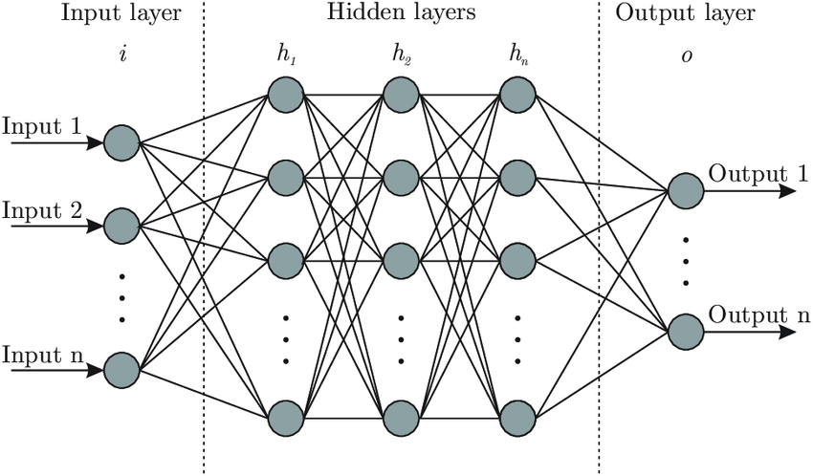

1. **CONVOULUTION NEURAL NETWORKS**

Artificial Neural Networks

The idea of ANNs is based on the belief that working of human brain by making the right connections, can be imitated using silicon and wires as living neurons and dendrites.

The human brain is composed of 86 billion nerve cells called neurons. They are connected to other thousand cells by Axons. Stimuli from external environment or inputs from sensory organs are accepted by dendrites. These inputs create electric impulses, which quickly travel through the neural network. A neuron can then send the message to other neuron to handle the issue or does not send it forward.

ANNs are composed of multiple nodes, which imitate biological neurons of human brain. The neurons are connected by links and they interact with each other. The nodes can take input data and perform simple operations on the data. The result of these operations is passed to other neurons. The output at each node is called its activation or node value. Each link is associated with weight. ANNs are capable of learning, which takes place by altering weight values.

Neural network:

A neural network is a network or circuit of neurons, or in a modern sense, an artificial neural network, composed of artificial neurons or nodes. Thus, a neural network is either a biological neural network, made up of real biological neurons, or an artificial neural network, for solving artificial intelligence (AI) problem. The connections of the biological neuron are modeled as weights. A positive weight reflects an excitatory connection, while negative values mean inhibitory connections. All inputs are modified by a weight and summed. This activity is referred as a linear combination. Finally, an activation function controls the amplitude of the output. For example, an acceptable range of output is usually between 0 and 1, or it could be - 1 and 1.

These artificial networks may be used for predictive modeling, adaptive control and applications where they can be trained via a dataset. Self-learning resulting from experience can occur within networks,

which can derive conclusions from a complex and seemingly unrelated set of information.

A deep neural network (DNN) is an artificial neural network (ANN) with multiple layers between the input and output layers. The DNN finds the correct mathematical manipulation to turn the input into the output, whether it be a linear relationship or a non-linear relationship.

CONVOLUTIONAL NEURAL NETWORKS:

Convolutional Neural Networks are very similar to ordinary Neural Networks from the previous chapter: they are made up of neurons that have learnable weights and biases. Each neuron receives some inputs, performs a dot product and optionally follows it with a non-linearity.

Convolutional Neural Networks (CNNs) are analogous to traditional ANNs in that they are comprised of neurons that self-optimize through learning. Each neuron will still receive an input and perform a operation (such as a scalar product followed by a non-linear function) - the basis of countless ANNs. From the input raw image vectors to the final output of the class score, the entire of the network will still express a single perceptive score function (the weight). The last layer will contain loss functions associated with the classes, and all of the regular tips and tricks developed for traditional ANNs still apply.

The only notable difference between CNNs and traditional ANNs is that CNNs are primarily used in the field of pattern recognition within images. This allows us to encode image-specific features into the architecture, making the network more suited for image-focused tasks - whilst further reducing the parameters required to set up the model. One of the largest limitations of traditional forms of ANN is that they tend to struggle with the computational complexity required to compute image data. Common machine learning benchmarking datasets such as the MNIST database of handwritten digits are suitable for most forms of ANN, due to its relatively small image dimensionality of just 28 × 28. With this dataset a single neuron in the first hidden layer will contain 784 weights (28×28×1 where 1 bear in mind that MNIST is normalized to just black and white values), which is manageable for most forms of ANN. If you consider a more substantial colored image input of 64 × 64, the number of weights on just a single neuron of the first layer increases substantially to 12, 288. Also take into account that to deal with this scale of input, the network will also need to be a lot larger than one used to classify color-normalized MNIST digits, then you will understand the drawbacks of using such models.

CNN ARCHITECTURE:

CNNs are feedforward networks in that information flow takes place in one direction only, from their inputs to their outputs. Just as artificial neural networks (ANN) are biologically inspired, so are CNNs. The visual cortex in the brain, which consists of alternating layers of simple and complex cells (Hubel & Wiesel, 1959, 1962), motivates their architecture.

CNN architectures come in several variations; however, in general, they consist of convolutional and pooling (or subsampling) layers, which are grouped into modules. Either one or more fully connected layers, as in a standard feedforward neural network, follow these modules. Modules are often stacked on top of each other to form a deep model. It illustrates typical CNN architecture for a toy image classification task. An image is input directly to the network, and this is followed by several stages of convolution and pooling. Thereafter, representations from these operations feed one or more fully connected layers.

Finally, the last fully connected layer outputs the class label. Despite this being the most popular base architecture found in the literature, several architecture changes have been proposed in recent years with the objective of improving image classification accuracy or reducing computation costs. Although for the remainder of this section, we merely fleetingly introduce standard CNN architecture.

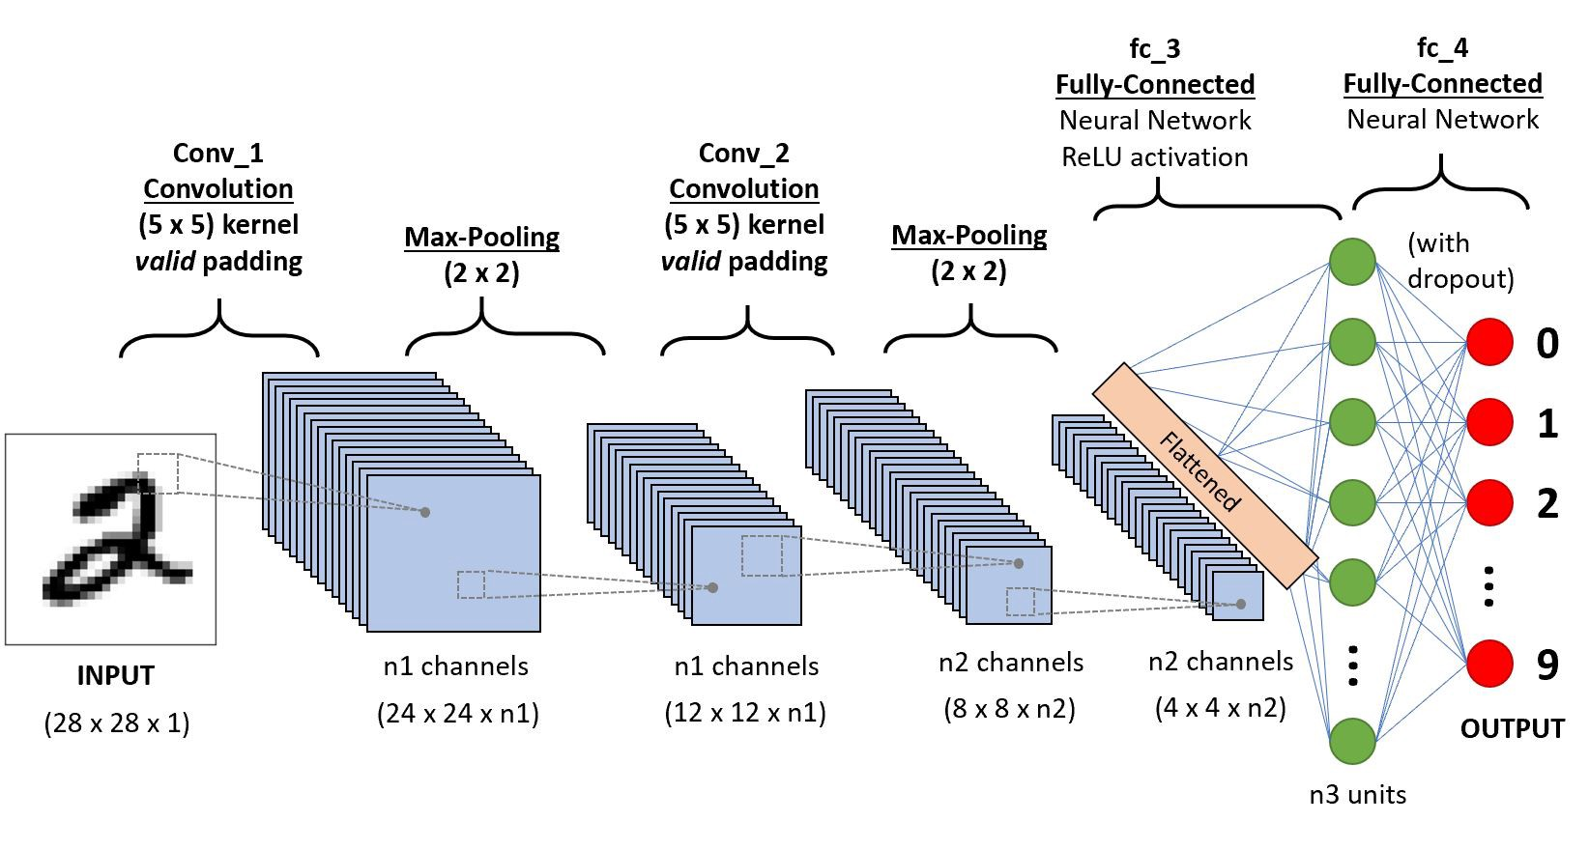

CNNs are comprised of three types of layers. These are convolutional layers, pooling layers and fully- connected layers. When these layers are stacked, a CNN architecture has been formed. A simplified CNN architecture for MNIST classification is illustrated in Figure 2. input 0 9 convolution w/ReLu pooling output fully-connected w/ ReLu fully-connected ... Fig. 2: A simple CNN architecture, comprised of just five layers the basic functionality of the example CNN above can be broken down into four key areas. 1. As found in other forms of ANN, the input layer will hold the pixel values of the image. 2. The convolutional layer will determine the output of neurons of which are connected to local regions of the input through the calculation of the scalar product between their weights and the region connected to the input volume. The rectified linear unit (commonly shortened to ReLu) aims to apply an ’elementwise’ activation function such as sigmoid to the output of the activation produced by the previous layer. 3. The pooling layer will then simply perform down sampling along the spatial dimensionality of the given input, further reducing the number of parameters within that activation. 4. The fully-connected layers will then perform the same duties found in standard ANNs and attempt to produce class scores from the activations, to be used for classification. It is also suggested that ReLu may be used between these layers, as to improve performance. Through this simple method of transformation, CNNs are able to transform the original input layer by layer using convolutional and down sampling techniques to produce class scores for classification and regression purposes. However, it is important to note that simply understanding the overall architecture of a CNN architecture will not suffice. The creation and optimization of these models can take quite some time, and can be quite confusing. We will now explore in detail the individual layers, detailing their hyperparameters and connectivity.

CONVOLUTIONAL LAYERS:

The convolutional layers serve as feature extractors, and thus they learn the feature representations of their input images. The neurons in the convolutional layers are arranged into feature maps. Each neuron in a feature map has a receptive field, which is connected to a neighborhood of neurons in the previous layer via a set of trainable weights, sometimes referred to as a filter bank. Inputs are convolved with the learned weights in order to compute a new feature map, and the convolved results are sent through a nonlinear activation function.

All neurons within a feature map have weights that are constrained to be equal; however, different feature maps within the same convolutional layer have different weights so that several features can be extracted at each location.

As the name implies, the convolutional layer plays a vital role in how CNNs operate. The layers parameters focus around the use of learnable kernels.

These kernels are usually small in spatial dimensionality, but spreads along the entirety of the depth of the input. When the data hits a convolutional layer, the layer convolves each filter across the spatial dimensionality of the input to produce a 2D activation map. These activation maps can be visualized.

As we glide through the input, the scalar product is calculated for each value in that kernel. From this the network will learn kernels that ’fire’ when they see a specific feature at a given spatial position of the input. These are commonly known as activations.

The center element of the kernel is placed over the input vector, of which is then calculated and replaced with a weighted sum of itself and any nearby pixels.

Every kernel will have a corresponding activation map, of which will be stacked along the depth dimension to form the full output volume from the convolutional layer.

As we alluded to earlier, training ANNs on inputs such as images results in models of which are too big to train effectively. This comes down to the fully connected manner of stan are ANN neurons, so to mitigate against this every neuron in a convolutional layer is only connected to small region of the input volume. The dimensionality of this region is commonly referred to as the receptive field size of the neuron. The magnitude of the connectivity through the depth is nearly always equal to the depth of the input.

For example, if the input to the network is an image of size 64 × 64 × 3 (aRGBcoloured image with a dimensionality of 64 × 64) and we set the receptive field size as 6 × 6, we would have a total of 108 weights on each neuron within the convolutional layer. (6 × 6 × 3 where 3 is the magnitude of connectivity across the depth of the volume) To put this into perspective, a standard neuron seen in other forms of ANN would contain 12, 288 weights each.

Convolutional layers are also able to significantly reduce the complexity of the model through the optimization of its output. These are optimized through three hyperparameters, the depth, the stride and setting zero-padding.

The depth of the output volume produced by the convolutional layers can be manually set through the number of neurons within the layer to the same region of the input. This can be seen with other forms of ANNs, where the all of the neurons in the hidden layer are directly connected to every single neuron beforehand. Reducing this hyperparameter can significantly minimize the total number of neurons of the network, but it can also significantly reduce the capabilities of the model.

We are also able to define the stride in which we set the depth around the spatial dimensionality of the input in order to place the receptive field. For example, if we were to set a stride as 1, then we would have a heavily overlapped receptive field producing extremely large activations. Alternatively, setting the stride to a greater number will reduce the amount of overlapping and produce an output of lower spatial dimensions.

Zero-padding is the simple process of padding the border of the input, and is an effective method to give further control as to the dimensionality of the output volumes.

It is important to understand that through using these techniques, we will alter the spatial dimensionality of the convolutional layers output.

Despite our best efforts so far, we will still find that our models are still enormous if we use an image input of any real dimensionality. However, methods have been developed as to greatly curtail the overall number of parameters within the convolutional layer.

Parameter sharing works on the assumption that if one region feature is useful to compute at a set spatial region, then it is likely to be useful in another region. If we constrain each individual activation map within the output volume to the same weights and bias, then we will see a massive reduction in the number of parameters being produced by the convolutional layer.

As a result of this as the backpropagation stage occurs, each neuron in the output will represent the overall gradient of which can be totaled across the depth - thus only updating a single set of weights, as opposed to every single one.

Pooling Layers

The purpose of the pooling layers is to reduce the spatial resolution of the feature maps and thus achieve spatial invariance to input distortions and translations. Initially, it was common practice to use average pooling aggregation layers to propagate the average of all the input values, of a small neighborhood of an image to the next layer. However, in more recent models, max pooling aggregation layers propagate the maximum value within a receptive field to the next layer.

Pooling layers aim to gradually reduce the dimensionality of the representation, and thus further reduce the number of parameters and the computational complexity of the model.

The pooling layer operates over each activation map in the input, and scales its dimensionality using the “MAX” function. In most CNNs, these come in the form of max-pooling layers with kernels of a dimensionality of 2 × 2 applied with a stride of 2 along the spatial dimensions of the input. This scales the activation map down to 25% of the original size - whilst maintaining the depth volume to its standard size.

Due to the destructive nature of the pooling layer, there are only two generally observed methods of max-pooling. Usually, the stride and filters of the pooling layers are both set to 2 × 2, which will allow the layer to extend through the entirety of the spatial dimensionality of the input. Furthermore, overlapping pooling may be utilized, where the stride is set to 2 with a kernel size set to 3. Due to the destructive nature of pooling, having a kernel size above 3 will usually greatly decrease the performance of the model.

It is also important to understand that beyond max-pooling, CNN architectures may contain general- pooling. General pooling layers are comprised of pooling neurons that are able to perform a multitude of common operations including L1/L2-normalisation, and average pooling. However, this tutorial will primarily focus on the use of max-pooling.

Fully Connected Layers

Several convolutional and pooling layers are usually stacked on top of each other to extract more abstract feature representations in moving through the network. The fully connected layers that follow these layers interpret these feature representations and perform the function of high-level reasoning. For classification problems, it is standard to use the SoftMax operator on top of a DCNN. While early success was enjoyed by using radial basis functions (RBFs), as the classifier on top of the convolutional towers found that replacing the SoftMax operator with a support vector machine (SVM) leads to improved classification accuracy.

The fully-connected layer contains neurons of which are directly connected to the neurons in the two adjacent layers, without being connected to any layers within them. This is analogous to way that neurons are arranged in traditional forms of ANN.

Despite the relatively small number of layers required to form a CNN, there is no set way of formulating a CNN architecture. That being said, it would be idiotic to simply throw a few of layers together and expect it to work. Through reading of related literature, it is obvious that much like other forms of ANNs, CNNs tend to follow a common architecture. This common architecture is illustrated in Figure 2, where convolutional layers are stacked, followed by pooling layers in a repeated manner before feeding forward to fully-connected layers.

Convolutional Neural Networks differ to other forms of Artificial Neural Network in that instead of focusing on the entirety of the problem domain, knowledge about the specific type of input is exploited. This in turn allows for a much simpler network architecture to be set up.

This paper has outlined the basic concepts of Convolutional Neural Networks, explaining the layers required to build one and detailing how best to structure the network in most image analysis tasks.

Research in the field of image analysis using neural networks has somewhat slowed in recent times. This is partly due to the incorrect belief surrounding the level of complexity and knowledge required to begin modelling these superbly powerful machine learning algorithms. The authors hope that this paper has in some way reduced this confusion, and made the field more accessible to beginners.

Training

CNNs and ANN in general use learning algorithms to adjust their free parameters in order to attain the desired network output. The most common algorithm used for this purpose is backpropagation. Backpropagation computes the gradient of an objective function to determine how to adjust a network’s parameters in order to minimize errors that affect performance. A commonly experienced problem with training CNNs, and in particular DCNNs, is overfitting, which is poor performance on a held-out test set after the network is trained on a small or even large training set. This affects the model’s ability to generalize on unseen data and is a major challenge for DCNNs that can be assuaged by regularization.

1. **YOLO v3**

What is YOLO?

YOLO is an abbreviation for the term ‘You Only Look Once’. This is an algorithm that detects and recognizes various objects in a picture (in real-time). Object detection in YOLO is done as a regression problem and provides the class probabilities of the detected images.

YOLO algorithm employs convolutional neural networks (CNN) to detect objects in real-time. As the name suggests, the algorithm requires only a single forward propagation through a neural network to detect objects.

This means that prediction in the entire image is done in a single algorithm run. The CNN is used to predict various class probabilities and bounding boxes simultaneously.

The YOLO algorithm consists of various variants. Some of the common ones include tiny YOLO and YOLOv3.

Why the YOLO algorithm is important

YOLO algorithm is important because of the following reasons:

Speed: This algorithm improves the speed of detection because it can predict objects in real-time.

High accuracy: YOLO is a predictive technique that provides accurate results with minimal background errors.

Learning capabilities: The algorithm has excellent learning capabilities that enable it to learn the representations of objects and apply them in object detection.

How the YOLO algorithm works

YOLO algorithm works using the following three techniques:

Residual blocks

Bounding box regression

Intersection Over Union (IOU)

Residual blocks

First, the image is divided into various grids. Each grid has a dimension of S x S. The following image shows how an input image is divided into grids. 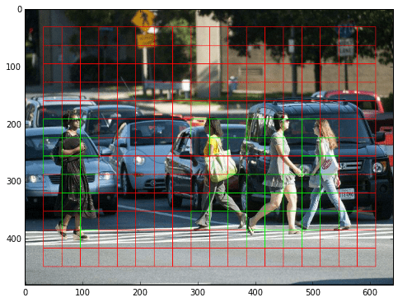

In the image above, there are many grid cells of equal dimension. Every grid cell will detect objects that appear within them. For example, if an object center appears within a certain grid cell, then this cell will be responsible for detecting it.

Bounding box regression

A bounding box is an outline that highlights an object in an image.

Every bounding box in the image consists of the following attributes:

Width (bw)

Height (bh)

Class (for example, person, car, traffic light, etc.)- This is represented by the letter c.

Bounding box center (bx,by)

The following image shows an example of a bounding box. The bounding box has been represented by a yellow outline.

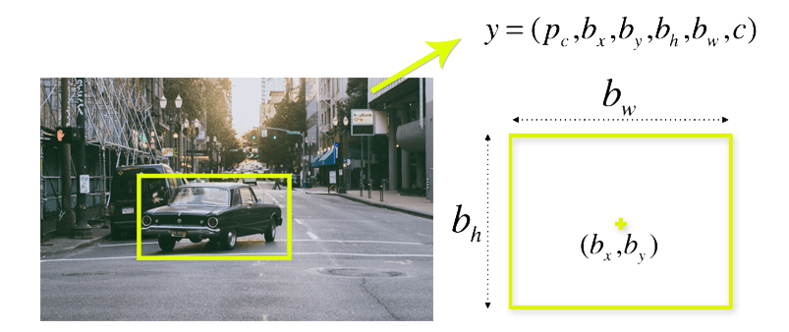

YOLO uses a single bounding box regression to predict the height, width, center, and class of objects. In the image above, represents the probability of an object appearing in the bounding box.

Intersection over union (IOU)

Intersection over union (IOU) is a phenomenon in object detection that describes how boxes overlap. YOLO uses IOU to provide an output box that surrounds the objects perfectly.

Each grid cell is responsible for predicting the bounding boxes and their confidence scores. The IOU is equal to 1 if the predicted bounding box is the same as the real box. This mechanism eliminates bounding boxes that are not equal to the real box.

The following image provides a simple example of how IOU works.

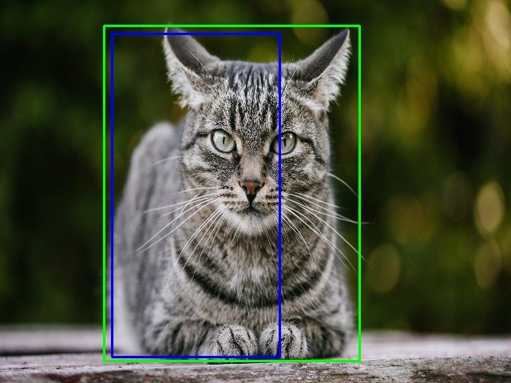

In the image above, there are two bounding boxes, one in green and the other one in blue. The blue box is the predicted box while the green box is the real box. YOLO ensures that the two bounding boxes are equal.

Combination of the three techniques

The following image shows how the three techniques are applied to produce the final detection results.

How YOLO Algorithm Works

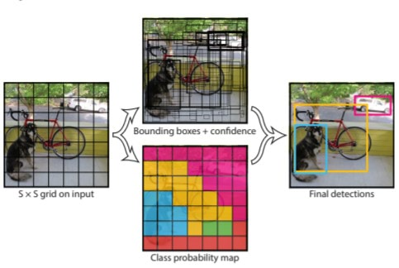

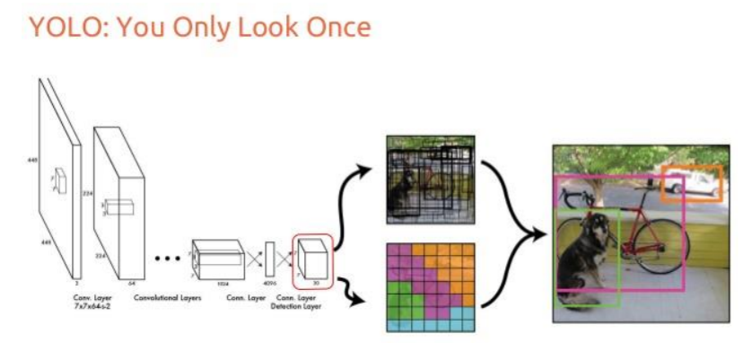First, the image is divided into grid cells. Each grid cell forecasts B bounding boxes and provides their confidence scores. The cells predict the class probabilities to establish the class of each object.

For example, we can notice at least three classes of objects: a car, a dog, and a bicycle. All the predictions are made simultaneously using a single convolutional neural network.

Intersection over union ensures that the predicted bounding boxes are equal to the real boxes of the objects. This phenomenon eliminates unnecessary bounding boxes that do not meet the characteristics of the objects (like height and width). The final detection will consist of unique bounding boxes that fit the objects perfectly.

For example, the car is surrounded by the pink bounding box while the bicycle is surrounded by the yellow bounding box. The dog has been highlighted using the blue bounding box.

Applications of YOLO

YOLO algorithm can be applied in the following fields:

Autonomous driving: YOLO algorithm can be used in autonomous cars to detect objects around cars such as vehicles, people, and parking signals. Object detection in autonomous cars is done to avoid collision since no human driver is controlling the car.

Wildlife: This algorithm is used to detect various types of animals in forests. This type of detection is used by wildlife rangers and journalists to identify animals in videos (both recorded and real-time) and images. Some of the animals that can be detected include giraffes, elephants, and bears.

Security: YOLO can also be used in security systems to enforce security in an area. Let’s assume that people have been restricted from passing through a certain area for security reasons. If someone passes through the restricted area, the YOLO algorithm will detect him/her, which will require the security personnel to take further action.

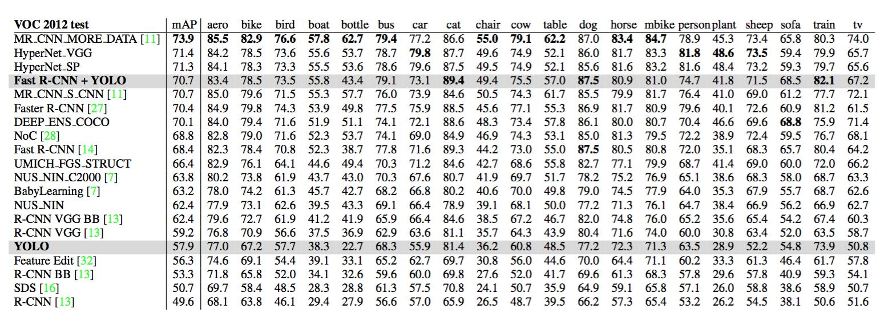

1. **SCREENSHOT**

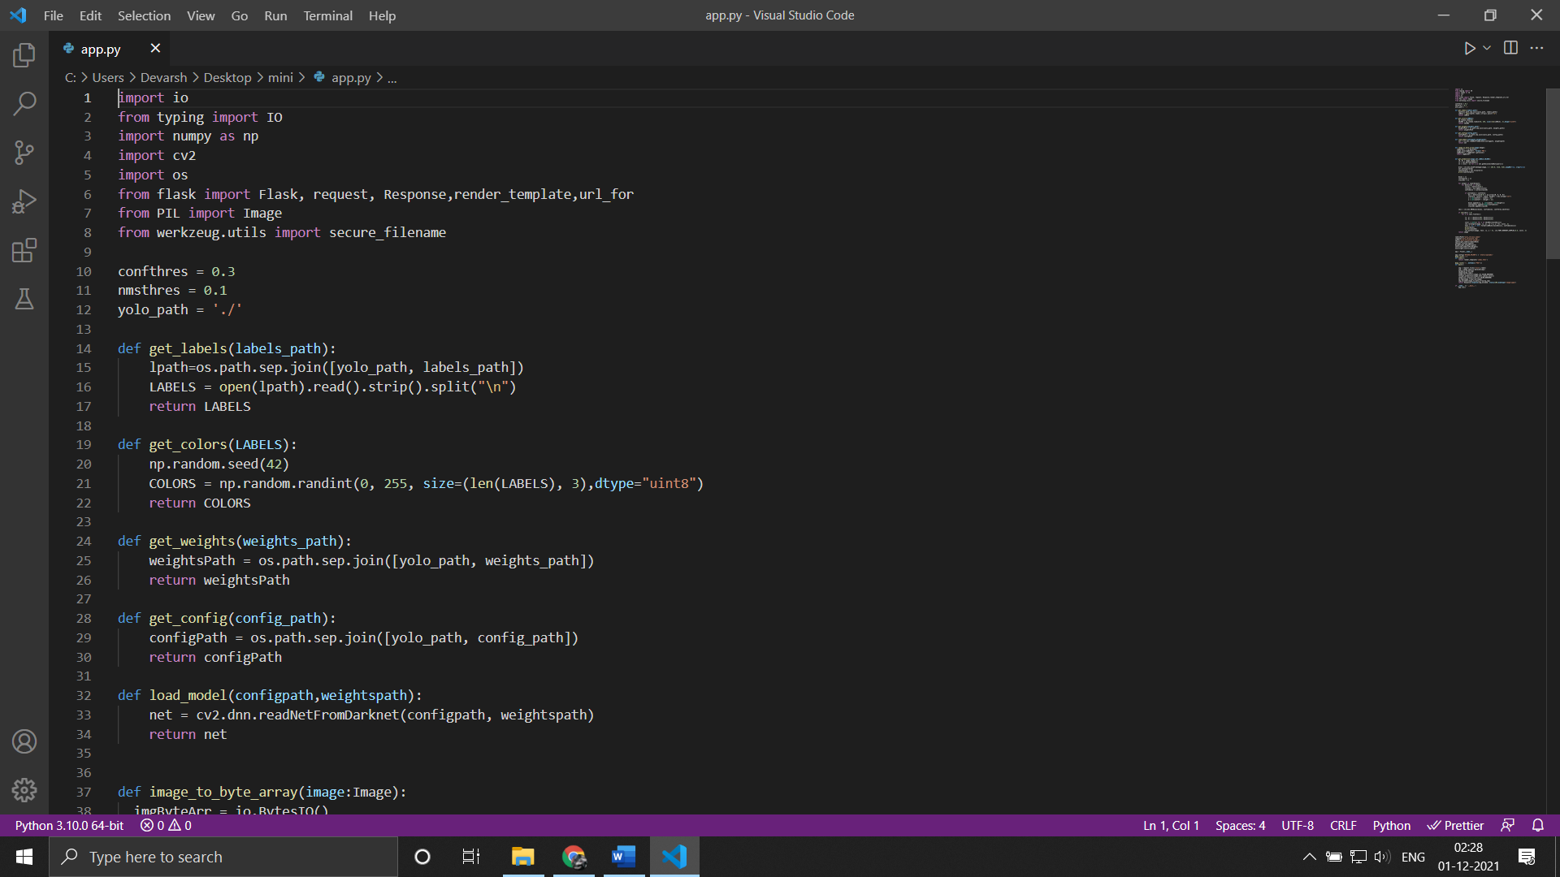

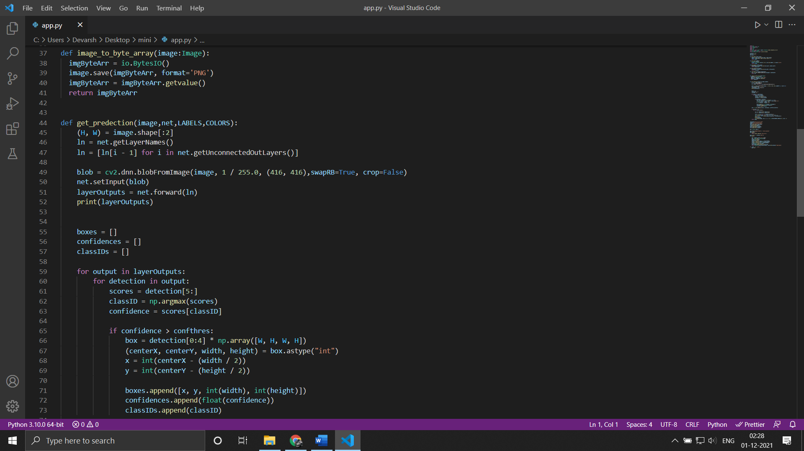

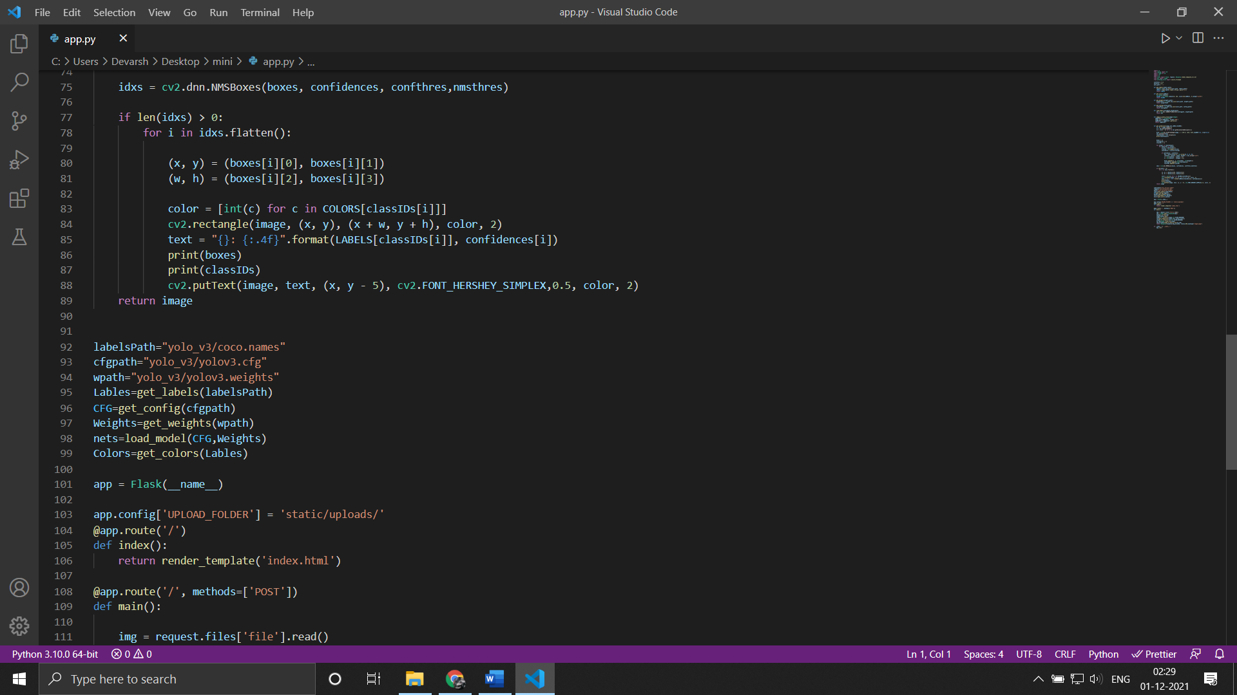

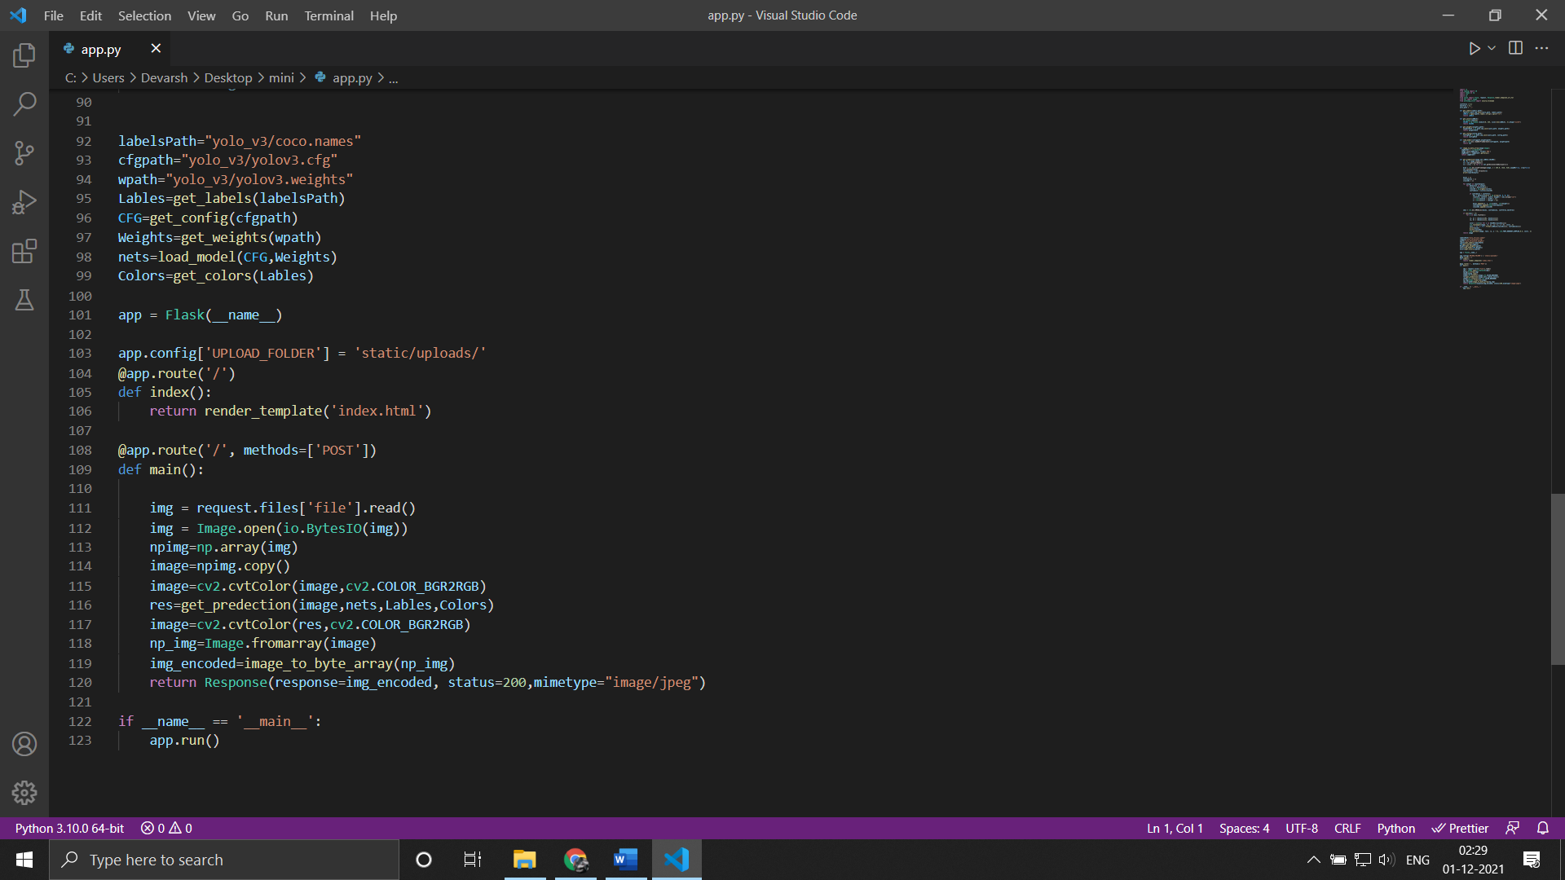

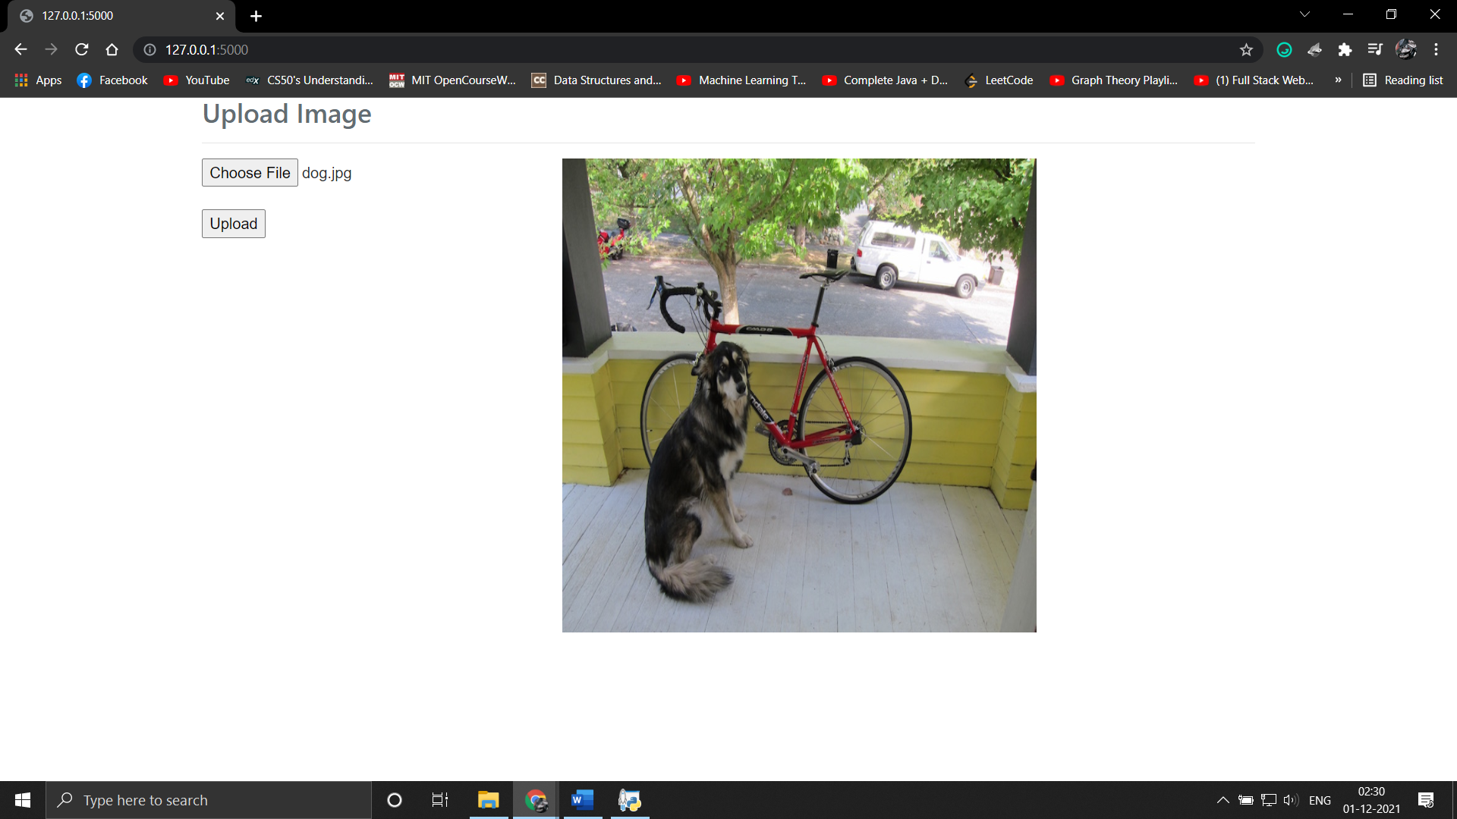

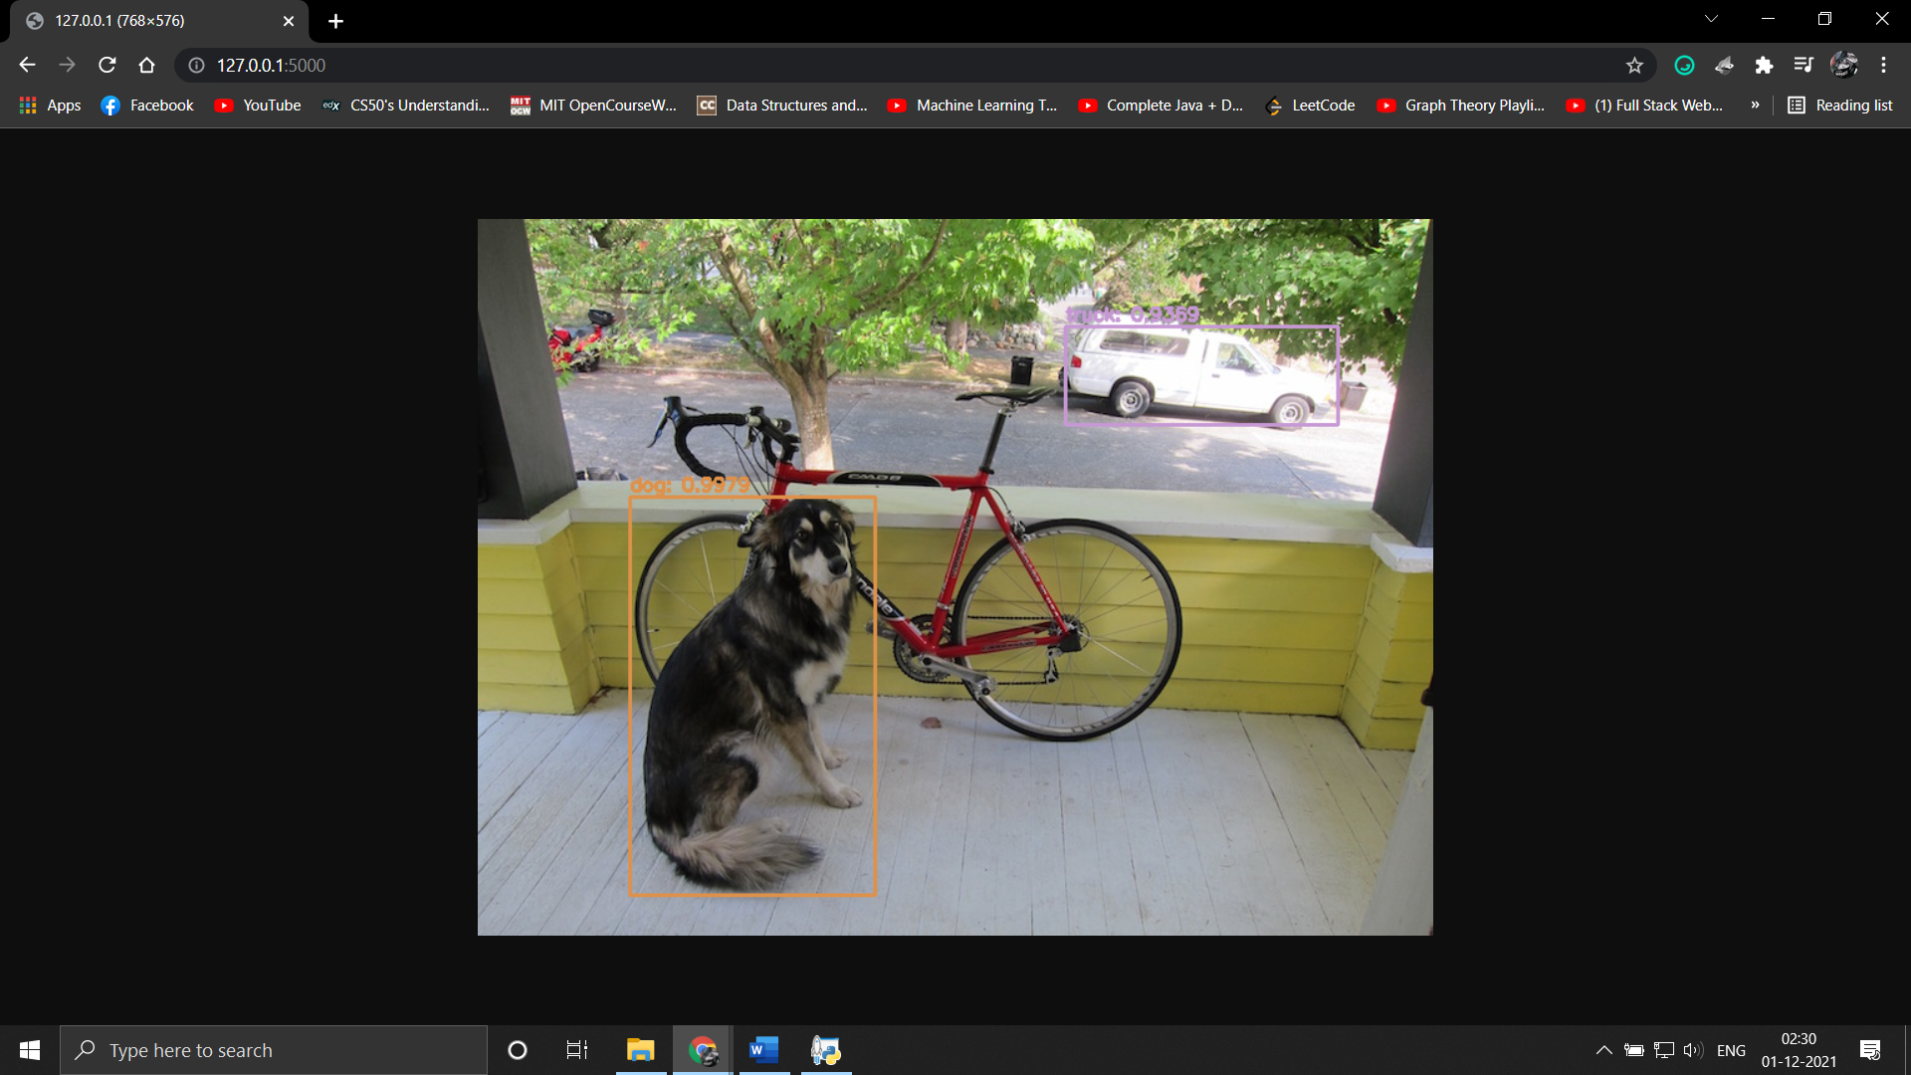

1. **APPLICATION OF OBJECT DETECTION**

Tracking objects

An item/object detection framework is additionally utilized in tracking the objects, for instance tracking a ball during a match in the football world cup, tracking the swing of a cricket bat, tracking an individual in a video.

Object tracking has an assortment of uses, some of which are surveillance and security, traffic checking, video correspondence, robot vision and activity.

People Counting

Object detection can be additionally utilized for People counting. It is utilized for dissecting store execution or group measurements during festivals. These will, in general, be progressively troublesome as individuals move out of the frame rapidly (likewise in light of the fact that individuals are non-inflexible objects).

Automated CCTV surveillance

Surveillance is a necessary piece of security and watch. Ongoing advances in computer vision innovation need to prompt the improvement of different programmed surveillance systems. Be that as it may, their viability is influenced by numerous factors and they are not totally dependable. This examination researched the capability of an automated surveillance system to diminish the CCTV administrator outstanding task at hand in both discovery and following exercises.

Typically, CCTV is running inevitably, so we need a huge size of the memory framework to store the recorded video. By utilizing an object discovery framework, we can mechanize CCTV so that in the event that a few items are detected, at that point the record is going to begin. Utilizing this we can diminish the over and over account a similar picture outlines, which expands memory effectiveness. We can diminish the memory prerequisite by utilizing this object detection system.

Person Detection

Person detection is necessary and critical work in any intelligent video surveillance framework, as it gives the essential data to semantic comprehension of the video recordings. It has a conspicuous augmentation to automotive applications because of the potential for improving security frameworks. Person detection is undertakings of Computer vision frameworks for finding and following individuals. Person detection is the task of finding all examples of individuals present in a picture, and it has been most broadly achieved via looking through all areas in the picture, at all potential scales, and contrasting a little region at every area with known layouts or examples of individuals. Person detection is commonly viewed as the initial procedure in a video surveillance pipeline and can take care of into more significant level thinking modules, for example, action recognition and dynamic scene analysis.

Vehicle Detection

Vehicle Detection is one of the most important part in our daily life. As the world is moving faster and the numbers of cars are kept on increasing day by day, Vehicle detection is very important. By using Vehicle Detection technique, we can detect the number plate of a speeding car or accident affected car. This also enables for security of the society and decreasing the number of crimes done by car. By using Vehicle Detection Technology Pixel Solutionz have successfully detected the speed of the vehicle and we have also detected the number plate of the car using Optical Character Recognition (OCR). By detecting the Number plate, Pixel Solutionz managed to measure the speed of the vehicle and for and oil company we have successfully developed a Safety Alert System with collision detection warning alert.

1. **CONCLUSION**

In this mini project we created an app which uses YOLO algorithm for object detection and classification and deployed it using flask framework and it was able to detect various object within the uploaded image. The YOLO algorithm is faster and also detects fewer false positives.

1. **REFERENCES**

[1] <https://towardsdatascience.com/designing-your-neural-networks-a5e4617027ed>

[2] <https://www.section.io/engineering-education/introduction-to-yolo-algorithm-for-object-detection/>

[3] <https://towardsdatascience.com/object-detection-using-yolov3-and-opencv-19ee0792a420>

[4]<https://www.researchgate.net/publication/340145010_Object_Detection_Algorithm_Based_on_Improved_YOLOv3>